Test plan checklist

**VERSION 1.0**

|  |  |
| --- | --- |
| **DOCUMENT APPROVAL HISTORY** | |
| Prepared By |  |
| Reviewed By |  |
| Approved By | ***<<The person designated to review the contents of the test plan for completeness (e.g., Test Lead, Test Manager) is responsible for approving the checklist. Insert name(s) here and have them sign. >>*** |

DOCUMENT HISTORY

|  |  |  |  |
| --- | --- | --- | --- |
| **DOCUMENT REVISION HISTORY** | | | |
| Date | Document Version | Revision Description | Author |
| 02/08/2011 | 1.0 | Initial Version | A. Liszt |
|  |  |  |  |
|  |  |  |  |
|  |  |  |  |
|  |  |  |  |
|  |  |  |  |
|  |  |  |  |
|  |  |  |  |
|  |  |  |  |
|  |  |  |  |

TABLE OF CONTENTS

1. INTRODUCTION 1

2. sample test plan checklist 1

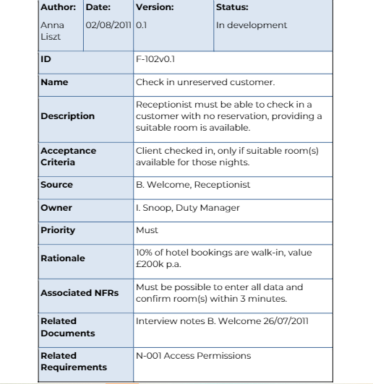

# INTRODUCTION

|  |  |  |  |
| --- | --- | --- | --- |
| Test Items | | | |
| 1 | Is the source of the requirement shown? (e.g., person, department) | Yes  No  N/A |  |
| 2 | Is each requirement testable? | Yes  No  N/A |  |
| 3 | Does each requirement have acceptance criteria? | Yes  No  N/A |  |
| 4 | Does each requirement/use case/user story have a unique identification? | Yes  No  N/A |  |
| 5 | Is there a version number for each requirement use case/user story? | Yes  No  N/A |  |
| 6 | Is this requirement traceable back to a business/marketing requirement? | Yes  No  N/A |  |
| 7 | Is there a traceability between requirements and/or use cases (if applicable)? | Yes  No  N/A |  |
| 8 | Do the requirements use consistent terminology (e.g., use a glossary)? | Yes  No  N/A |  |